LJ University
Integrated MBA-5 Year Program
(School of Management Studies)
A Report On
“Bizzest 2.0: 2024”

Date | 12th March, 2024
Program | Bizzest 2.0 2024
Venue | 4th Floor, LJIMBA, New Commerce Building
Semester | 2,4,6,8 and 10
Institute | IMBA- 5years Program (School of Management Studies), LJU
Number of Participants | 140

Date: 12/03/24

LJ- Integrated MBA 5 years program, school of management studies, organizes and conducts various events and activities around the year, as a part of co-curricular and extracurricular learning for the students. This year, LJ IMBA introduced a new managerial event, Bizzest, which is a management fest with a twist of fun and learning.

Bizzest, gave a platform to the students to showcase their ideas and how they plan to put it into action if given a chance to. Not only did the event helped students in brainstorming business ideas, design their ideas and present them, they also learned communication skills, marketing skills, bargaining skills, among various other learnings.

LJ IMBA's flagship event, Bizzest, returned in grand style for its second edition, Bizzest 2024, with the proud introduction of esteemed event partner Dizinfinity - Digital Marketing Academy. Dizinfinity isn't merely an academy; it's a gateway to the ever-evolving realm of digital marketing. With their cutting-edge courses and unwavering dedication to quality, they equip individuals with the skills and expertise essential to thrive in today's fiercely competitive market.

Bizzest 2024 unfolded with three captivating rounds, commencing with "Pitch Your Idea" in February. The round was held on two consecutive days, 24th and 26th February. A total of 40 teams participated in this round, vied for recognition from a discerning jury, presenting their business concepts with a focus on feasibility, cost analysis, revenue streams, and negotiation acumen.

Advancing to the subsequent round, "Buy Out" on March 7th. 35 teams engaged in spirited bidding to secure stalls. The number of stalls were limited to 26 stalls (8 Economy Stalls, 8 Executive Stalls and 10 Premium Stalls) amongst 35 teams.
These stalls were categorized into 3 formats:
- Economy Stalls: Bids for these stalls started at Rs. 400
- Executive Stalls: bids for these stalls started at Rs. 600
- Premium Stalls: bids for these stalls started at Rs. 800. What’s special about the premium stalls this time was that these stalls were facilitated with a power connection, giving a competitive edge to teams.

The grand finale of Bizzest 2024, branded as the "Bizzest Mela", was held on March 12th. During this event, twenty-six teams, driven by their entrepreneurial ambitions, showcased their distinct products, varying from arts and handicrafts to food and beverages. The teams manned their stalls from 8:00 am to 4:00 pm conducting all the transactions in Bizzest Currency.

The event buzzed with excitement, fueled by fascinating student performances and faculty-led games, fostering an atmosphere of shared enthusiasm and accomplishment.

The success of Bizzest 2024 was a testament to the collaborative efforts of LJ IMBA's faculty, event partner Dizinfinity – Way to Infinite Success, jury members, participants, enthusiastic audience and student coordinators (volunteers). LJ IMBA remains steadfast in its commitment to nurturing entrepreneurial spirit and experiential learning, with Bizzest serving as a beacon of innovation and excellence.

Few Memories of the event:

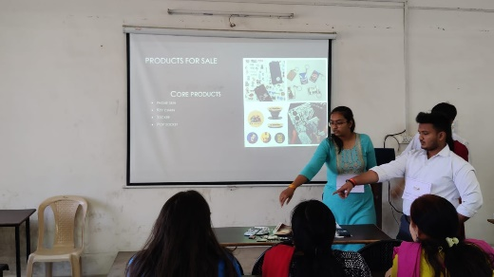 | 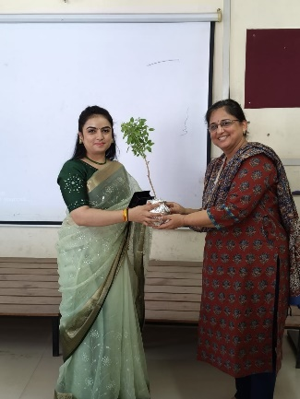 | 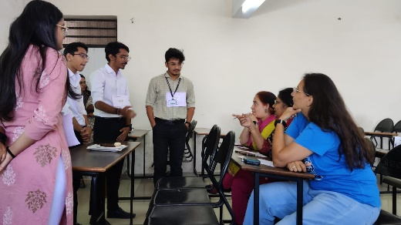
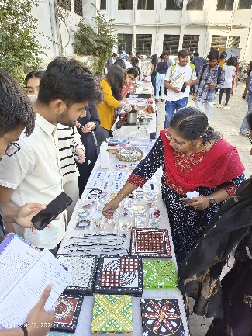 | 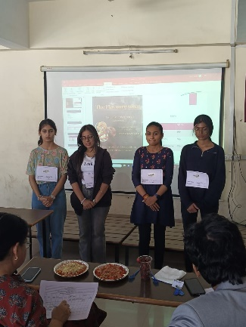 | 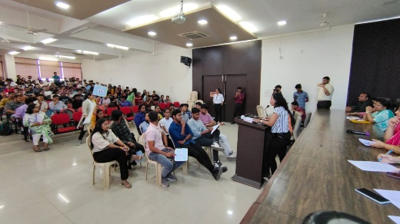
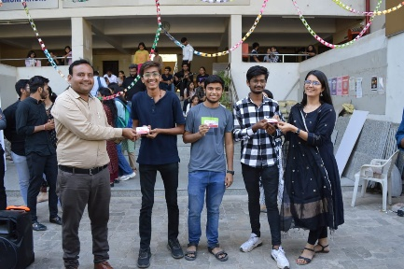 | 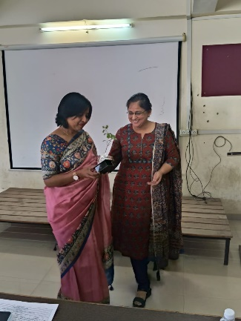 | 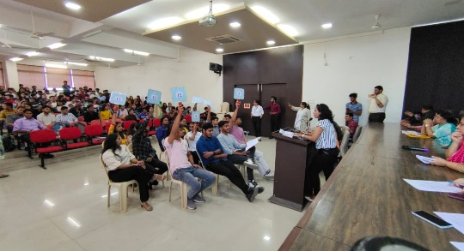
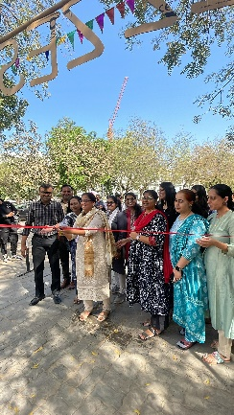 | 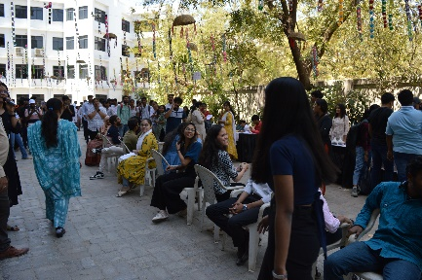 | 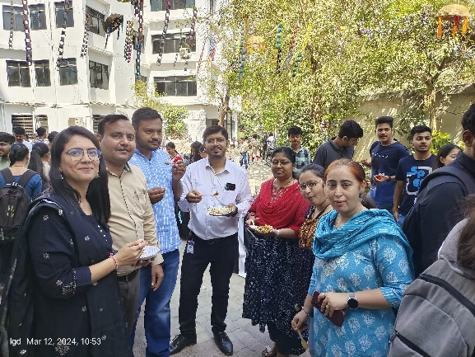
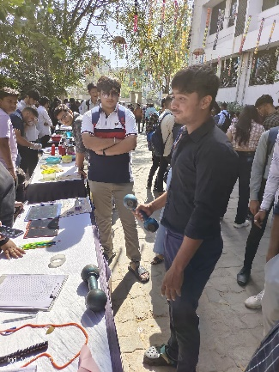 | 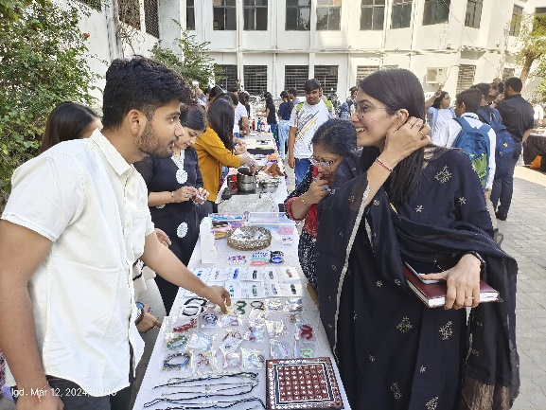 | 